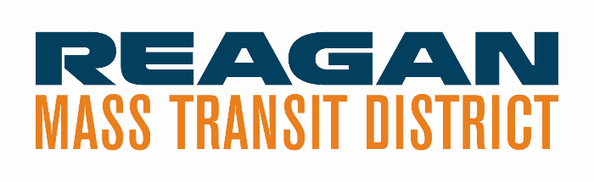

AGENDA

Meeting of RMTD Governing Board
June 13, 2024, | 4:30 PM
210 E Progress Drive, Dixon, IL

Roll Call @ 4:30 PM ☒Ermir Ramadani, Board Chair
☒Greg Sparrow, Vice-Chair
☒Aaqil Khan, Treasurer
☒Larry Callant, Board Member

☒Greg Gates, Executive Director, RMTD
☐Rob LeSage, Attorney (Absent)
☐Matt Cole, Attorney (Absent)
☒Kendra Hull, Secretary (Virtual)

Guests - Kristy Jones, Manager of Finance
Steve Davis, Assistant Director Operations
Chet Olson

ACTION: Approval of Minutes - Discussion: No discussion
Motion: Greg Sparrow
Second Motion: - Aaqil Khan
Opposed: 0
Public Comment – No comments.

Executive Director

Closing on RMTD / June 28, 2024 - Section 218 – IMRF / FICA needs to be exercised. Lot of paperwork being
completed. Met with legal on Monday. Focused on finance – all on same page.

RFP Bids Going Out
Auditor RFP (Due in by June 26, 2024) - Quick turnaround. Rebroadcast for Federal in paper
tomorrow.
Marketing RFP
Data Analyst RFP / Transportation Desert Grant – done by Monday – Broadcast.

FY 2025 Contracts with IDOT - Wrapping up. Finishing final paperwork.

Rural Winnebago County Transit-Slow Walk into providing service.

Feasibility Studies - Good conversations. Tracking real routes. Final reports later August.

Visit with Chicago – Rockford International Airport - Start conversation regarding revenue. Generator to do
a shuttle. A potential chunk of interest.

Community Outreach - Completed events: Dixon Block Party and SVCC Child Fair.

Report – Operations

Ridership

Vehicles – 5 used, for disposed vehicles. Other vehicles coming.

Report – Financial

Financial Report – Income statement – through April. A good year. Cash based. Nothing out of proportion.

FY 2025 Budget – Budgets that we put into Black Cat for IDOT DOAP – 5311 includes expenses for WINN –
includes 65% of Match. Admin 80/20 mostly at beginning – ½ million without needing lock match. No
vehicles – 1 dispatch, 2 ½ drivers. Kristy explained budget lines with Black Cat – Greyhound as well as bottom line. Explained DOAP Spend Down. Explained eligible DOAP to pay for DOAP. Explained paying services. First Quarter Payout 5311 will have accrual for next time. Deposit for treasurer sent

Report – Human Resources (Absent)

Two Dispatchers and one PT Driver hired.

Old Business

Hydrogen Pilot Project – Still waiting for decision. This or next month.

Feasibility Studies for Dixon and Rochelle

State Planning and Research Grant / Transportation Desert

Rural Winnebago County Transit Services

New Business

RMTD Transition
Contracts transferring over

Section 218 Resolution (see attached) - . Section 218 required and social security to tax a State employee allows States to opt in.

Pass a resolution for positions for FICA and Social Security.
Motion: Aaqil Khan
Second Motion – Greg Sparrow
Opposed – 0

Oregon Construction – Add to next agenda – Property Expansion.

Expansion at 210 E. Progress Drive – put together a plan.

Solicitation for funding support

Other Business

Maintenance Center strategic plan.
Discussed monies at end of Fiscal for Lee and how they will transfer to RMTD. Look into other revenue
sources for RMTD.

Closing documents and contracts provided. Breadth of providers IDOT assigning contracts this week? Lee
to RMTD.

Utilities will continue relationships.

All documentation for government to be eligible with IDOT.

Bonding set up with Sub. Title work ready. Equipment listing and inventory completed.

Greg went over all attachments for the Definitive Agreement.

Secured 125 plan for tax savings.

Executive Session

Personnel

Adjourned at
Motion:
Second Motion:
Opposed:

Next Meeting: July 11, 2024 @ 4:30 PM

