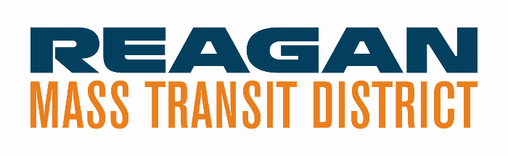

Meeting Minutes

Meeting of RMTD Governing Board
October 26, 2023, | 4:30 PM
210 E Progress Drive, Dixon, IL

1) Roll Call @ 4:28 PM ☒Jeremy Englund, Chair
☒Greg Sparrow, Vice-Chair
☐Aaqil Khan, Treasurer – not in attendance
☒Ermir Ramadani, Board Member
☐Larry Callant, Board Member – not in attendance

☒Greg Gates, Executive Director, RMTD
☐Rob LeSage, Attorney – not in attendance
☒Kendra Hull, Secretary
Guests - Marcus Cox, Assistant Director of Operations
Scott Brinkmeier, Lee County

2) ACTION: Approval of Minutes - Discussion:
Motion: Greg Sparrow
Second Motion: - Ermir Ramadani
Opposed: 0

3) Public Comment - Scott Brinkmeier made a public comment regarding his recent change in employment status.

4) Executive Director Report – See report attached.
Greg went over the report. Highlighting several “old business” and “new business” items.
Ridership Update
32% increase since last July in rides. It could be a result in post COVID, more inclined to use the vehicles, school associated trips, largest ridership day yesterday, October 25, 2023. A lot of these come from schools which help to bring up our daily rides. Families are covering the cost of the rides.

5) Old Business
  - Update: Definitive Agreement on Asset Transfer
    - Hoping we will get word from IDOT Chief Counsel this week, which would allow for a lot of pieces to start rolling.
    - We are hoping to bring this to the county boards next month.

  - Financial Policies and Procedures
    - Banking Services – went through the process and waiting on IDOT. Once we receive concurrence we can move forward. This will be discussed with the Board at next month’s meeting. Steve Davis will provide this update.
    - Audit and Obligations for CPA – we are going to distribute a request for clarifications and put out a notice for bids. This will be brought to both IDOT and the RMTD Board.
Are there certain requirements that the auditor will need? The auditor needs to be reasonable, well-versed and working experience with government and/or transportation.

      - The Board would like to receive communication as to why decisions are being made and the basis for the choice of the successful vendors.

  - Hydrogen Pilot Project

Nothing new. Still waiting word in regard to funding. There is a 10 a.m. webinar tomorrow to have a basic conversation about a potential partnership in the future.

  - Feasibility Studies for Dixon and Rochelle

Been awarded and waiting on preaward concurrence from IDOT for the next step. Summer of
2024 to complete the two studies.

RLS and Associates has been chosen based on the review basis and after the concurrence with
IDOT. Six-to-nine-month window to complete the feasibility study.

6) New Business

a. State Planning and Research Grant Award / Transportation Desert

Looking at transportation in general, not just public transportation. What are the
transportation needs that are not being met in the Lee and Ogle area. We will be
engaging NIU who will be involved in this. Greg does not anticipate a long period of
time. We could have three feasibility studies going on at the same time.

b. Rural Winnebago County Services

This has slowed down until we get the definitive agreement approved. Greatest
concern is to get as much communication as possible to people in Winnebago county in
regards to this service. This is what we will be offering as of July 1st.

c. Amendments to Procurement Policy and Procedures

Distributed. Given the time frame we can push this off to a subsequent meeting. This
has been approved by Lee County with suggestions recommended by IDOT. This
updated policy will be shared with them so we can cross this off.

It is the desire of the board to have more of a robust conversation when all the board
members are present. The Procurement Policy and Procedures will need to be sent to all the board members along with the minutes prior to the next meeting.

For the most part we have used the Lee County Procurement as a guide.

7) Other Business

Financials – Greg went over the attached reports. The financial statement is through the end of
September 2023.

On the revenue side there is a Greyhound Route. We will be a bit more definitive on how we
report that. We did receive some income from the providers. We have received over $1.0 million in the last two weeks from the Illinois Comptroller’s Office, with an additional five (5) payments pending.

May and June have not been paid out from IDOT, as of yet. Greg and Kristy are keeping an eye
on this. There are four or five pending payments. We could ask for advance payment. Does LOTS have a day’s cash? It would involve a conversation with Lee County Treasurer’s Office.

We are doing prep work for the audits coming up. It is due 180 days after the close of the fiscal
year. The county is also wanting to do their county audit before the end of the year.

8) Executive Session – No Executive Session

9) Adjournment – 5:13 PM Motion: Ermir Ramadani
Second Motion: Greg Sparrow
Opposed: 0

Next Meeting – November 9, 2023 @ 4:30 PM

